The “Revised” Story Line!  (As re-worded by Atari Charles)  E.T. having returned to Earth, discovers that Space Invaders have invaded and conquered the Earth. E.T. Knows that he must rescue Elliot and the other Earthlings by making a neutron bomb with Earth technology. Once the neutron bomb is created, E.T. will call his ship, bring the weapon into space and launch it.  Little does E.T. know is that Howard Scott Warshaw has teamed up on the side on the Space Invaders to help them convert the Earth's environment into an environment very much like the Space Invader's home planet. The Space Invaders have promised Howard Scott Warshaw immunity from the I.R.S., worldwide distribution of his books, and ruler-ship over the area of California.  You are E.T.. Can you defeat the Space Invaders and Howard Scott Warshaw? | 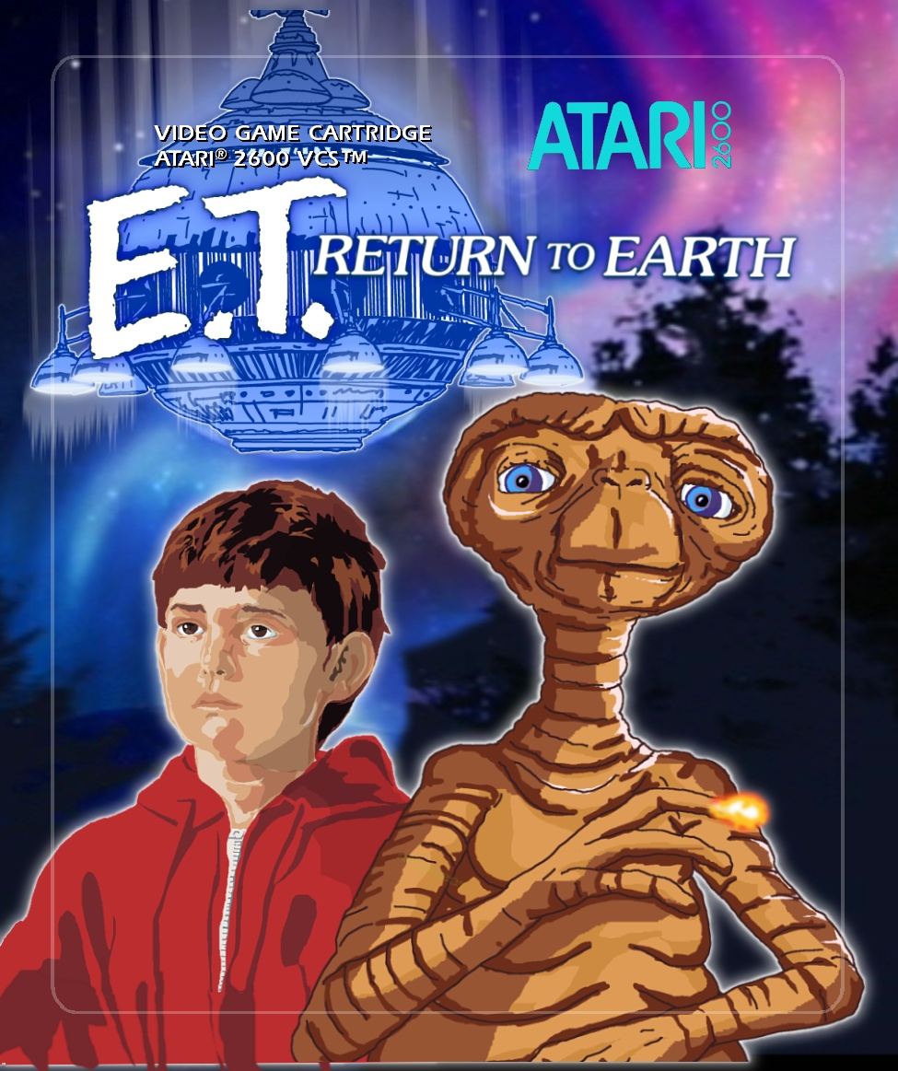
The “Revised” Story Line!
(As re-worded by Atari Charles)

E.T. having returned to Earth, discovers that Space Invaders have invaded and conquered the Earth. E.T. Knows that he must rescue Elliot and the other Earthlings by making a neutron bomb with Earth technology. Once the neutron bomb is created, E.T. will call his ship, bring the weapon into space and launch it.

Little does E.T. know is that Howard Scott Warshaw has teamed up on the side on the Space Invaders to help them convert the Earth's environment into an environment very much like the Space Invader's home planet. The Space Invaders have promised Howard Scott Warshaw immunity from the I.R.S., worldwide distribution of his books, and ruler-ship over the area of California.

You are E.T.. Can you defeat the Space Invaders and Howard Scott Warshaw?
The History!  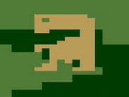  This cart was programmed by an American coder working for a boot leg company located in Taipei, Taiwan. The title screen reads: SAVE ELLIOT in English. Even though the game was never released, a single copy of it survived and was found in a private collection in Paris, France. The case is the normal Atari style, no label aside from a sticker with handwriting on it. Charles and others convinced the owner to allow the rom to be dumped and it is now available as an extremely limited release. | The Taiwan Story Line!  Along with the game was a crude typed black and white one page manual . The story line is typical of a Taiwanese pirated game, with the common broken-English strange wording that almost makes sense:  The E.T. is lonely for friend Elliot. The E.T. not wanting his kind turns to earth and find mars monsters that eat people and make prisoner to Elliot. The E.T. get angry and have to make Elliot safe. WATCH OUT! Mars monsters HUNGRY. Points go high if weapon made and the E.T. make Elliot safe on earth. If Elliot not rescue and time make zero, the E.T. will die too. You be brave. The E.T. must be brave to help friend Elliot and in truth she make earth happy and well.
The History!  This cart was programmed by an American coder working for a boot leg company located in Taipei, Taiwan. The title screen reads: SAVE ELLIOT in English. Even though the game was never released, a single copy of it survived and was found in a private collection in Paris, France. The case is the normal Atari style, no label aside from a sticker with handwriting on it. Charles and others convinced the owner to allow the rom to be dumped and it is now available as an extremely limited release. | The Taiwan Story Line!  Along with the game was a crude typed black and white one page manual . The story line is typical of a Taiwanese pirated game, with the common broken-English strange wording that almost makes sense:  The E.T. is lonely for friend Elliot. The E.T. not wanting his kind turns to earth and find mars monsters that eat people and make prisoner to Elliot. The E.T. get angry and have to make Elliot safe. WATCH OUT! Mars monsters HUNGRY. Points go high if weapon made and the E.T. make Elliot safe on earth. If Elliot not rescue and time make zero, the E.T. will die too. You be brave. The E.T. must be brave to help friend Elliot and in truth she make earth happy and well.

